**Project Design Phase-II**

**Technology Stack (Architecture & Stack)**

|  |  |
| --- | --- |
| Date | 03 October 2022 |
| Team ID | PNT2022TMID27752 |
| Project Name | Machine Learning based Vehicle Performance Analyzer |
| Maximum Marks | 4 Marks |

**Technical Architecture**

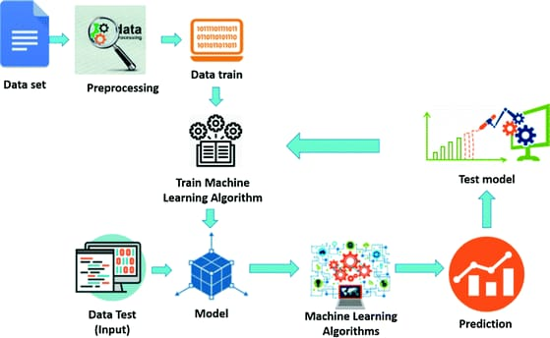

;

**Table-1: Components & Technologies:**

|  |  |  |  |
| --- | --- | --- | --- |
| **S No** | **Component** | **Description** | **Technology** |
| 1. | Application | User interacts with the prediction of vehicle behavior | Python, Java, HTML, SQL, Android studio, JavaScript |
| 2. | Database | Data Type, Configurations and data will be stored | MySQL, JavaScript |
| 3. | Cloud Database | Database Service on Cloud | IBM DB2, IBM Cloudland, etc. |
| 4. | Send User Report | Send the predictions to the users | REST API |
| 5. | Machine Learning | Purpose of Machine Learning Model | ANN, CNN, RNN |
| 6. | Database | Database contain user information such as name, email, vehicle information | MySQL |
| 7. | File Storage | File storage requirements | IBM Block Storage or Other Storage Service or Local Filesystem |
| 8. | External API | Vehicles details database | https://api.auto-data.net/ |
| 9. | Machine Learning Model | Purpose of Machine Learning Model | OpenCV, MATLAB |
| 10. | Infrastructure (Server / Cloud) | Application Deployment on Local System / Cloud Local Server Configuration:  Cloud Server Configuration : | Local, Cloud Foundry, Kubernetes, etc. |

**Table-2: Application Characteristics:**

|  |  |  |  |
| --- | --- | --- | --- |
| **S No** | **Characteristics** | **Description** | **Technology** |
| 1. | Open-Source Frameworks | Flask, Sci-kit learn | JavaScript, Python |
| 2. | Security Implementations | Identity and access management | IBM Cloud |
| 3. | Scalable Architecture | The scalability of architecture consists of 3 tiers Model-View-Controller Implementation | Web Server – HTML, CSS, JavaScript  Application Server – Python Flask  Database Server – IBM Cloud |
| 4. | Availability | Availability is increased by loads balancers in cloud  VPS | IBM Cloud hosting |
| 5. | Performance | The application is expected to handle up to 4000 predictions per second | IBM Load Balance |